- The index of the outliers removed: 365, 369, 370, 372, 373, 381, 406, 411, 415, 419.
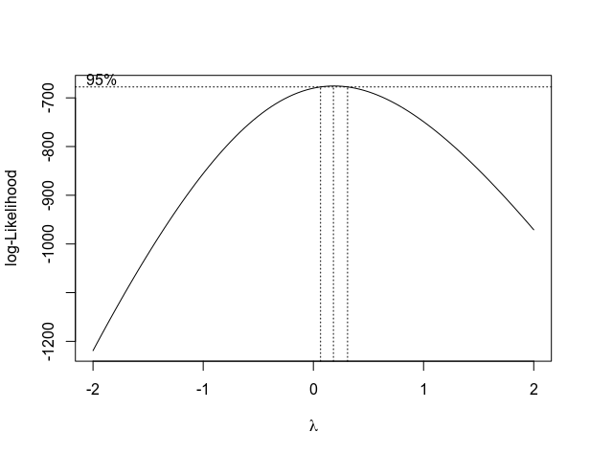
- Following is a box-cox plot of the lambda parameter and its log-likelihood. The best lambda is around 0.182.
Figure 1: The log-likelihood vs. parameter of box-cox transformation.

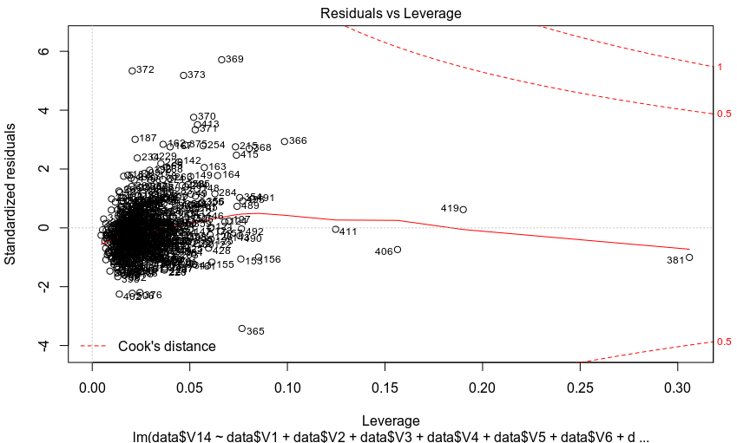
Figure 2: Standardized Residual vs. Leverage vs. Cook’s Distance plot with outliers.

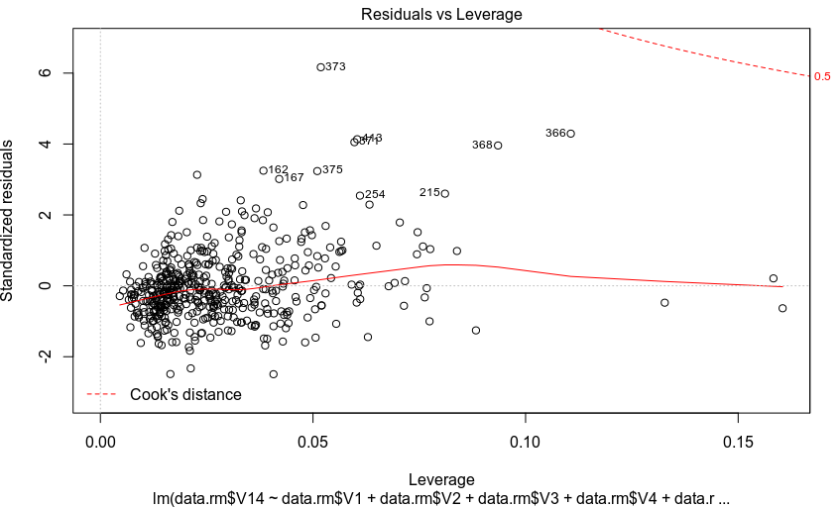
Figure 3: Standardized Residual vs. Leverage vs. Cook’s Distance plot without outliers.

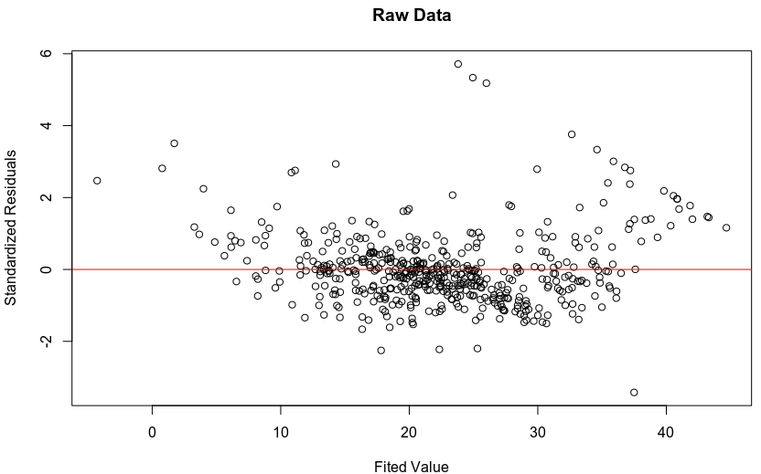
Figure 4: Standardized Residual vs. Fitted Values without transformation
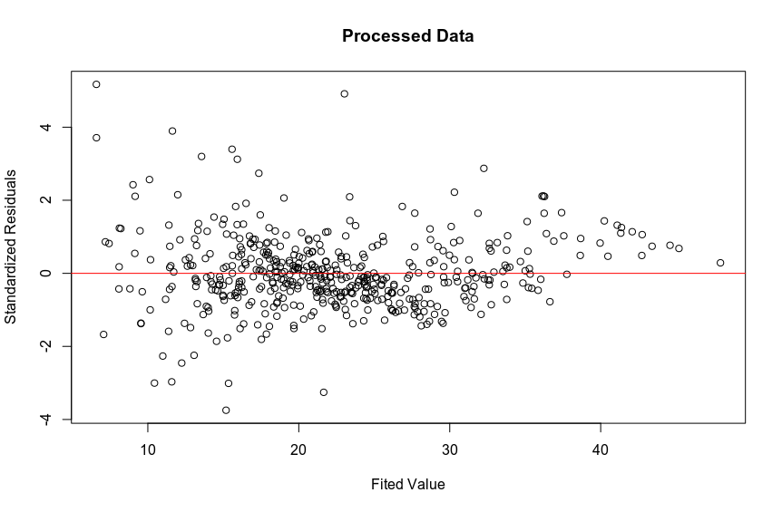
Figure 5: Std Residual vs. Fitted Values with 10 outliers removed & transforming the dependent variable

Comparing the above two graphs, we can observe that with transformation, the linear regression can yield results with standardized residuals that are closely center to 0 compared to the result generated by using original data.
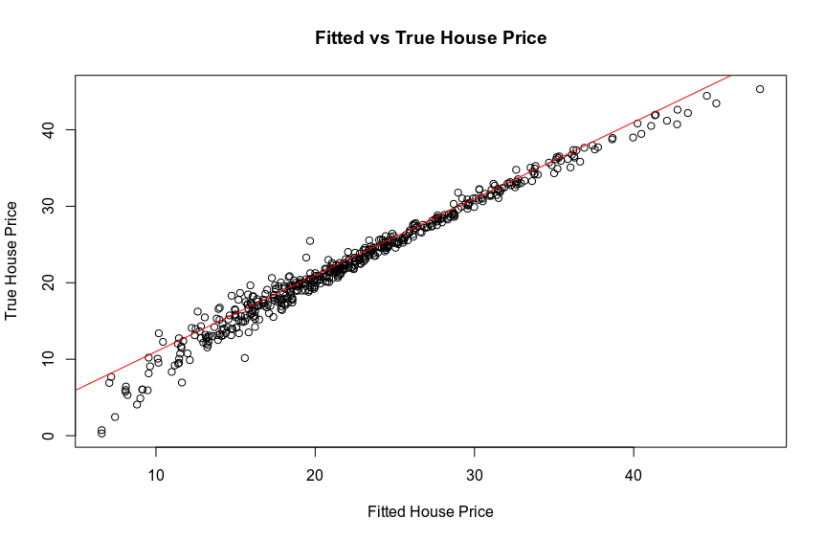
Figure 6: The plot of fitted house price vs true house price

From the above graph, we can observe that the plot of fitted house price vs true house price follows closely as the line of . This indicates that our linear regression has yielded desirable result.

